**EXP NO: 1**

**AIM:**  
To write an assembly language program to implement 8-bit addition using 8085  
processor.  
  
**ALGORITHM:**

1. Start the program by loading the first data into the accumulator.

2)  Move the data to a register.  
  
  
3)      Get the second data and load it into the accumulator.  
  
  
4)      Add the two register contents.  
  
  
5)      Check for carry.  
  
  
6)      Store the value of sum and carry in the memory location.  
  
  
7)      Halt.

**PROGRAM:**  
  
LDA 8500  
  
  
MOV B, A  
  
  
LDA 8501  
  
  
ADD B

  STA 8502  
  
  
 RST 1

**INPUT:**

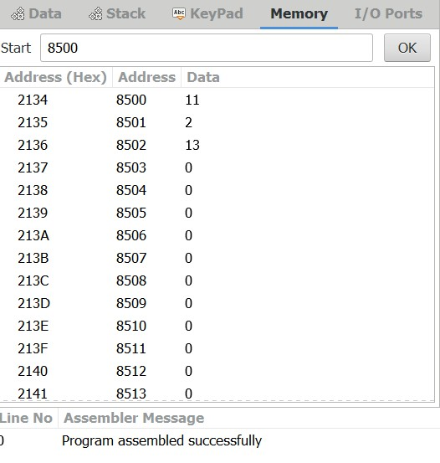

**OUTPUT:**

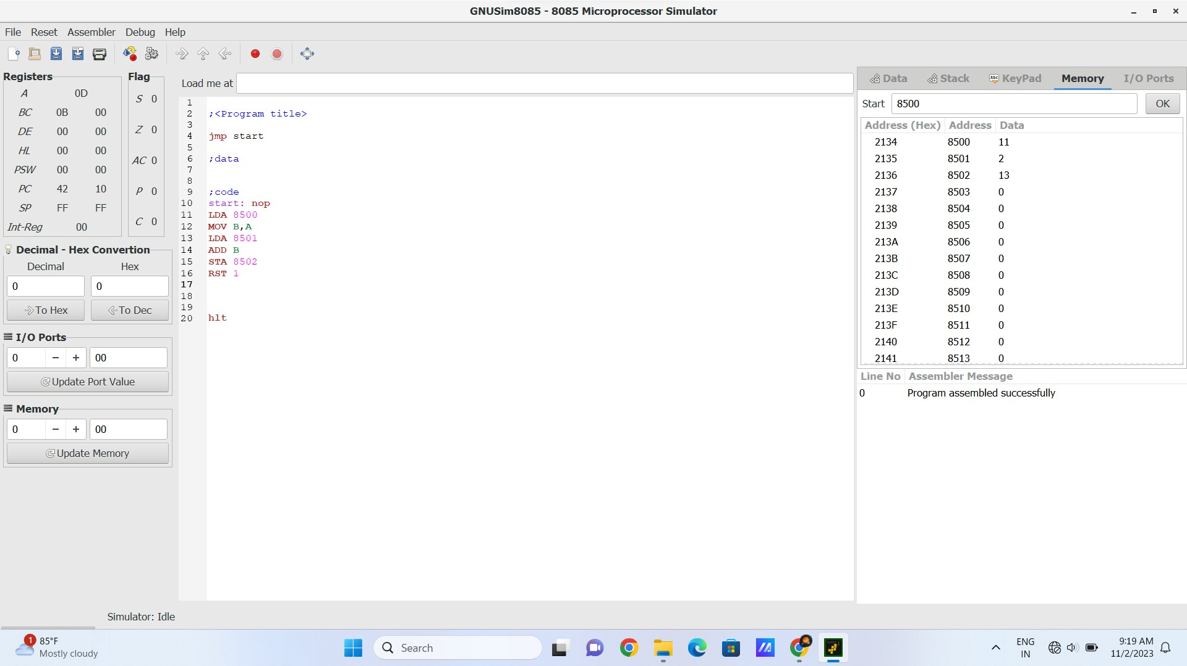  
  
  
   
**RESULT:** Thus the program was executed successfully  
using 8085 processor simulator.